**IN3005 Computer Graphics**

**Coursework Report**

**Tayyab Hussain**

Description of the game:

Annotated Screenshot of top-down view:

KBM Controls:

Asset Listings:

URL: Date of Download: License:

Reflection: (PUT THIS RIGHT AT THE BOTTOM)

***Route and Camera***

Route:

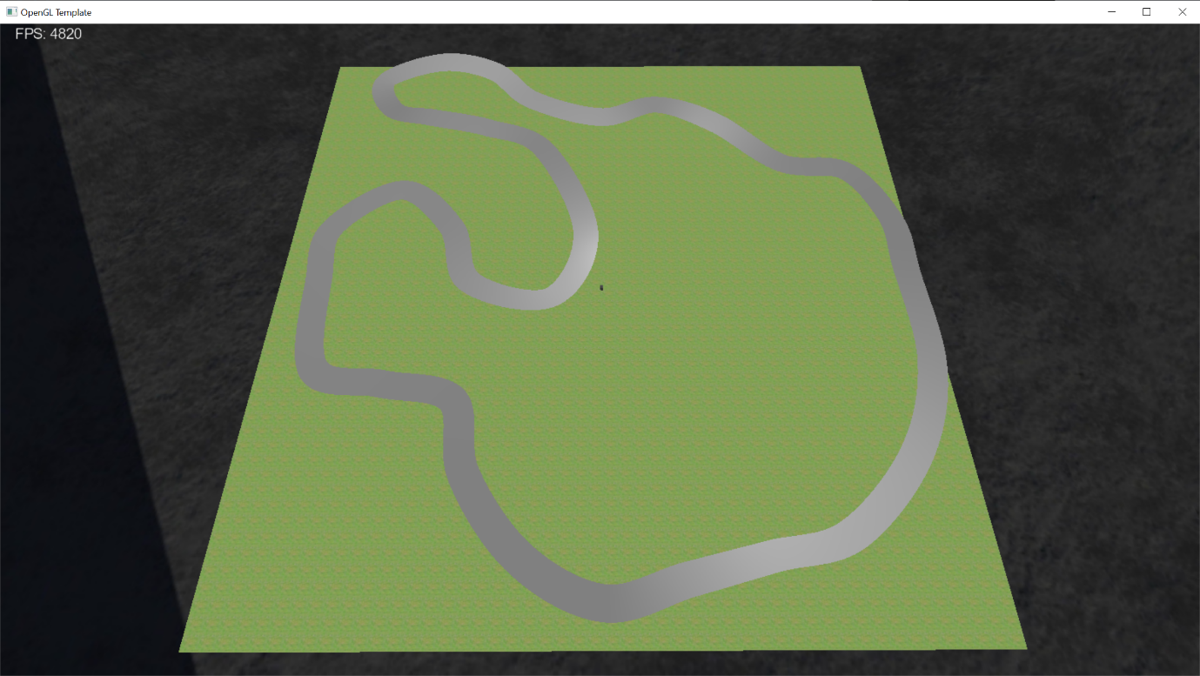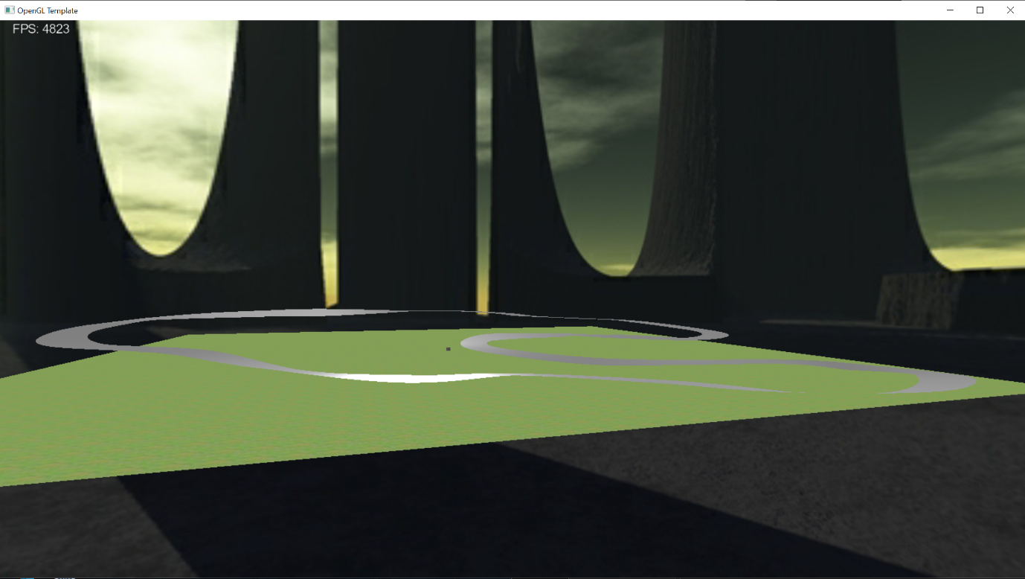This is the track I have created for my game. I implemented it using the Catmull-Rom spline. There are 33 points along the track, each with its own individual up-vector to create banked or off-camber corners.

After applying a texture to it, here is what the track looks like now: 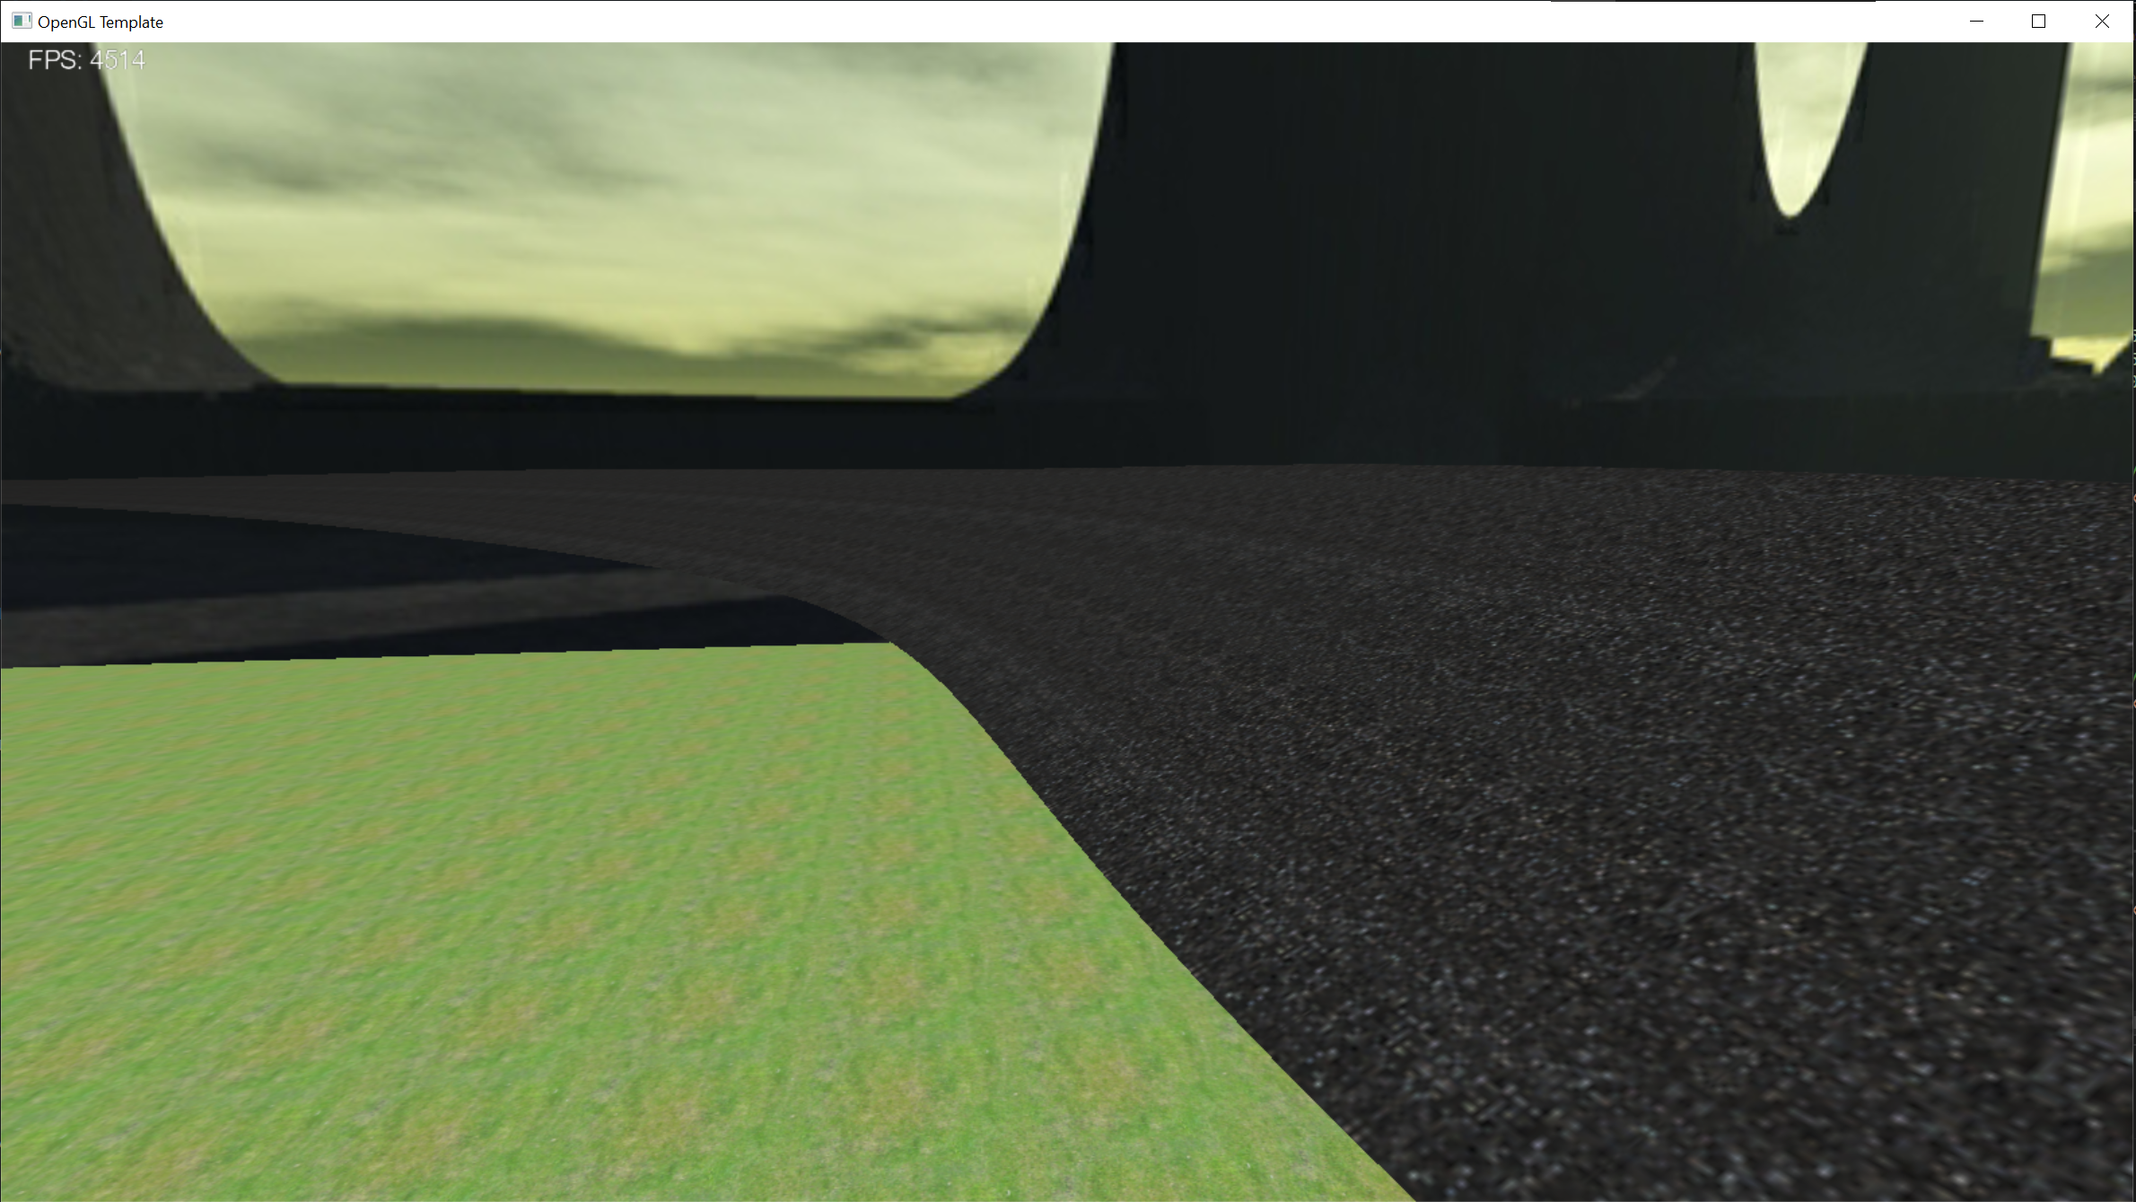

I added height-mapped terrain though it is very rudimentary. I designed it using Microsoft Paint 3D, so it doesn’t blend in well. I’m hoping that once I add some more meshes I can hide the rough edges of my heightmap.

I then placed my Tunnel primitive in 2 locations along the track and used a Catmull-Rom spline again to create 2 barricades on either side of the track. The barricades use the offset points (that create the track width) and a TNB frame from each of these points to position a new point above the current offset point in the direction of the centre line`s up vector.

I did have a few issues with the texturing of the barricades. Since both the track and the barricades had different textures, but they were part of the same class, only one texture would be applied to both objects. I could not find an elegant solution to this problem. I could’ve simply not applied a texture to the track or barricade, but I didn’t like how this looked. So instead, I created a new Catmull-Rom spline class and renamed it BarricadeSpline. This class is identical to the original in every way except that it doesn’t render anything other than the barricades and therefore I can use the main Catmull-Rom class to render that track and track texture and the barricade class to render the barricades and barricade texture.

This is what the track looks like as of now:

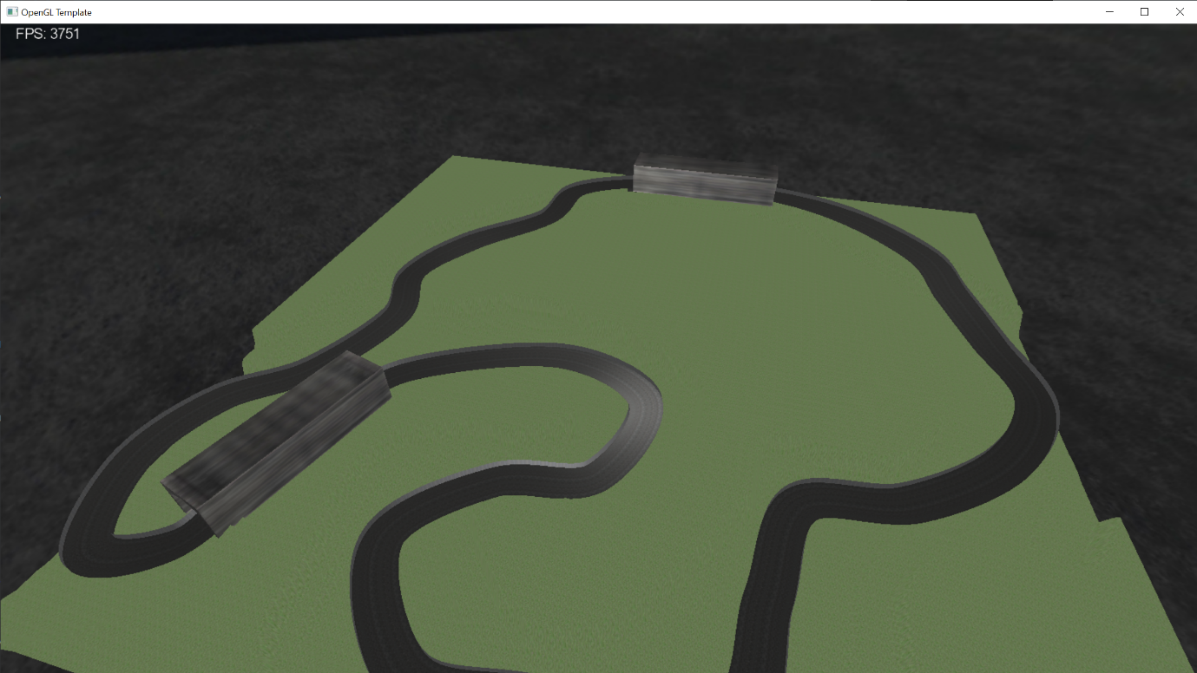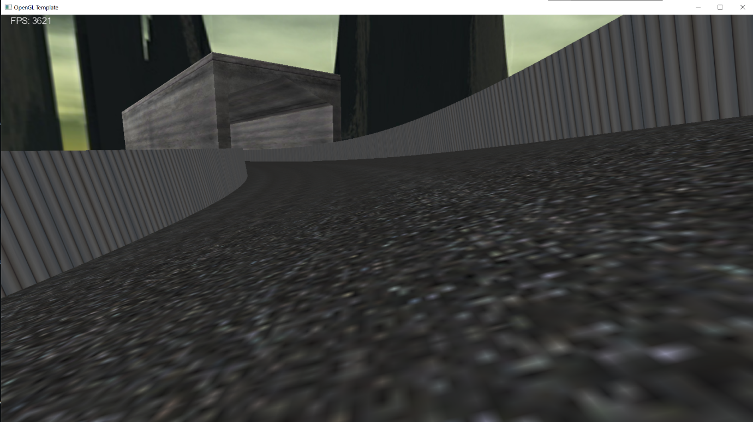

I also changed the skybox at this stage, to match the theme of my game more closely. This was the outcome: 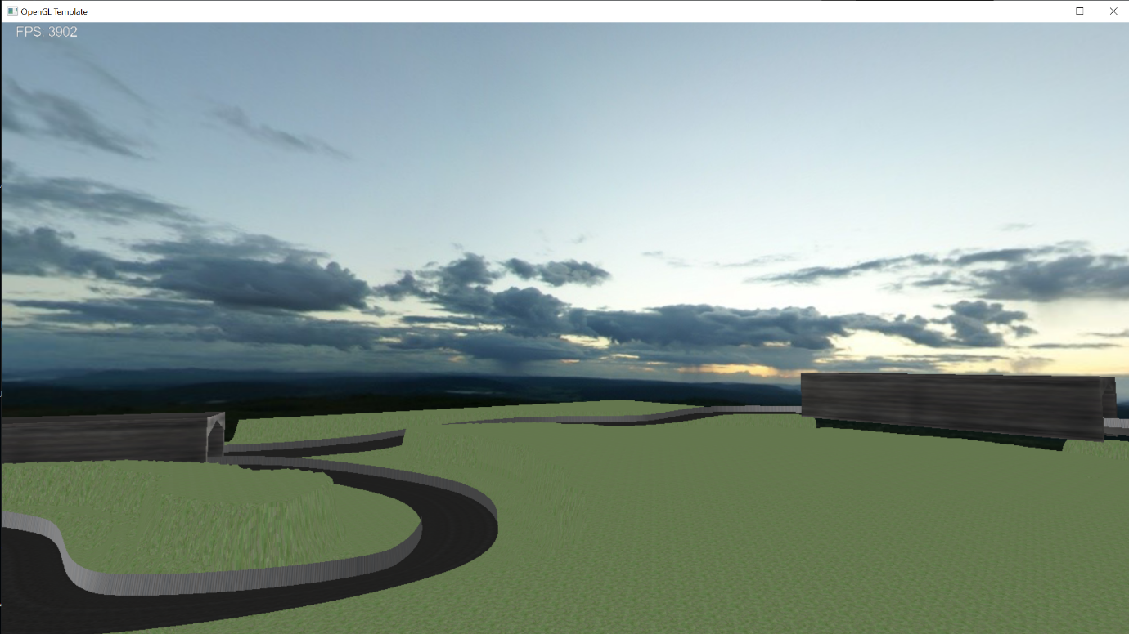

Camera:

The 2 camera modes I decided to add to my game were third-person and first-person. I have implemented keyboard controls to change between these 2 camera modes and the free-view camera (This has been detailed above).

The way I implemented this is by first adding a mesh(player car) to my game and specifying its position and orientation using a TNB frame calculated from the track spline. I then set the cameras relative to the player’s car, e.g. behind and above the car for the third-person camera. In terms of the keyboard controls, I used 3 boolean values for each of the cameras, third-person, first-person and free-view. In the code, once the corresponding key was pressed, I would set the related boolean value to true and set the others to false. Then in the update() method, the code checks to see which boolean is set to true and sets the camera accordingly.

These are what the 2 camera modes look like in my game: 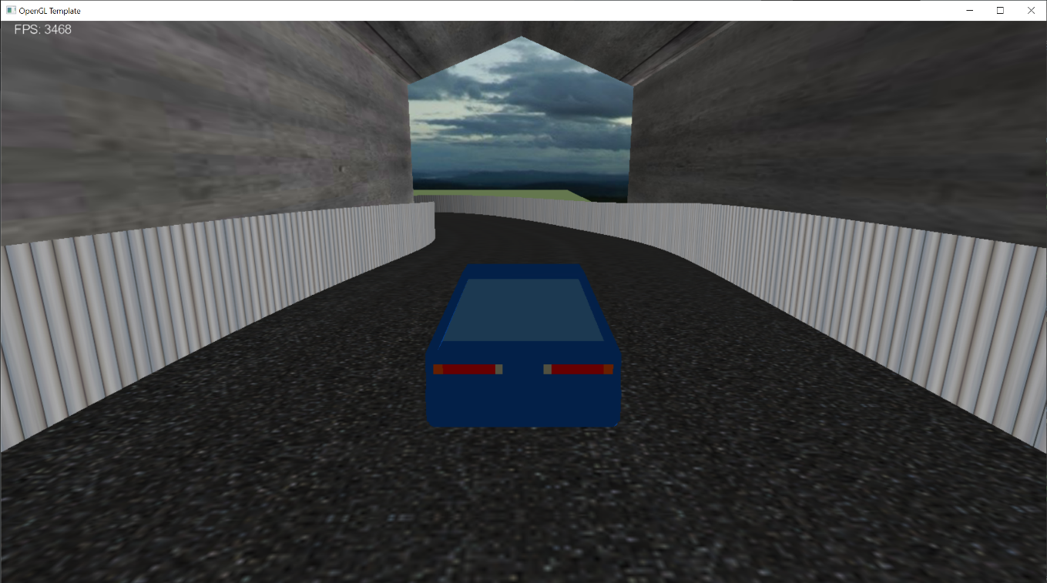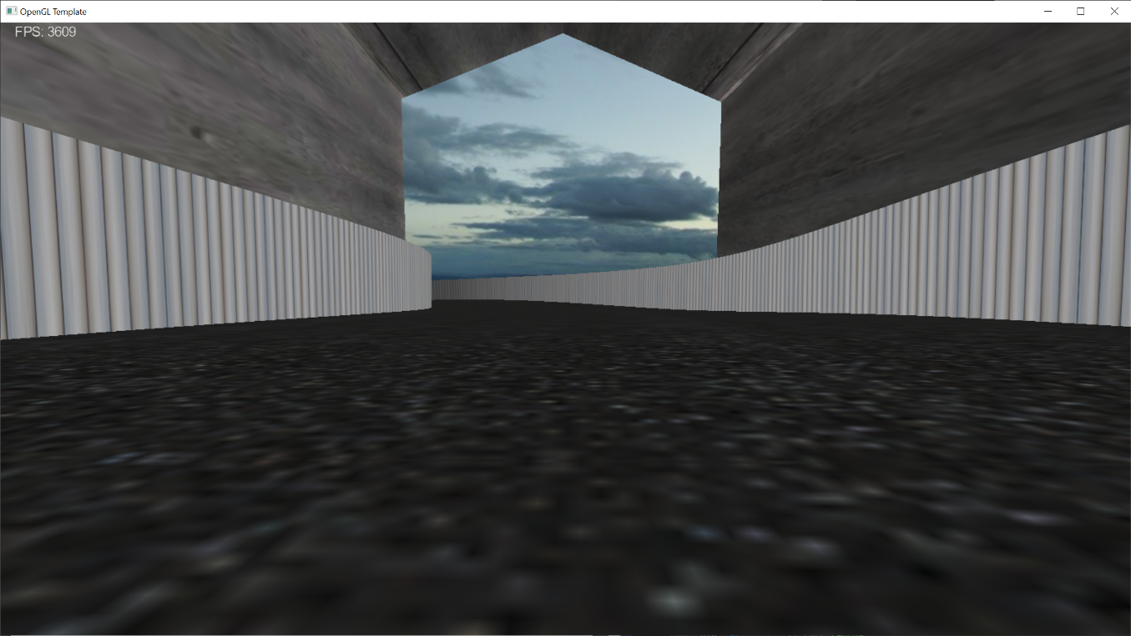

***Basic Objects, Meshes and Lighting***

Basic Objects:

The first basic object I have designed is a tunnel. The tunnel is defined in its own class and has its vertex attributes pushed into a vertex buffer object or VBO. The tunnel object also has its own shader program which applies the Phong lighting model. The lighting is calculated per-fragment as opposed to per-vertex as this results in higher quality shading. Also, within the fragment shader, I have mixed the colour of my object, which was stored in the VBO, with the texel colour. This allows me to have a bit more control over how the final texture of my object looks. Putting all this together, here is what my object looks like: 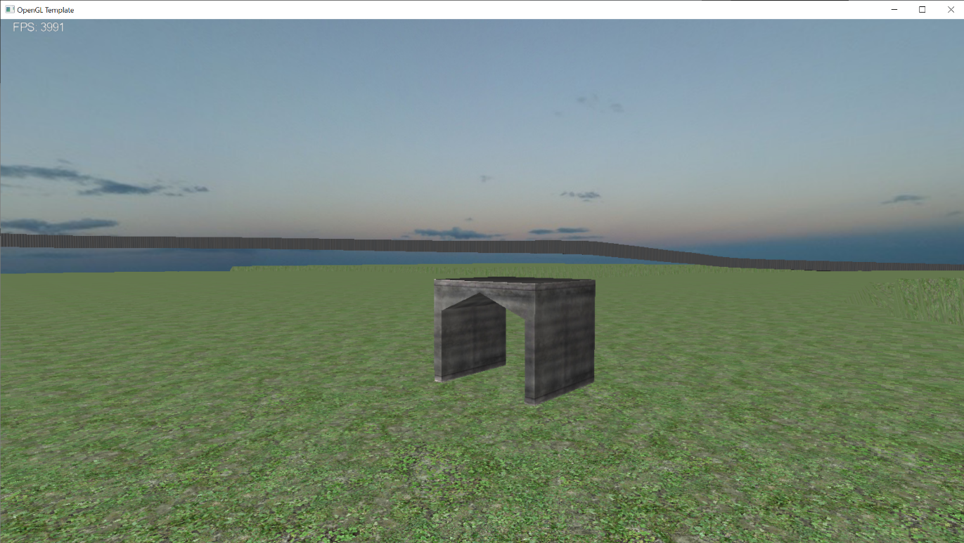After placing 2 transformed instances of my object into the game, here is what it looks like now: 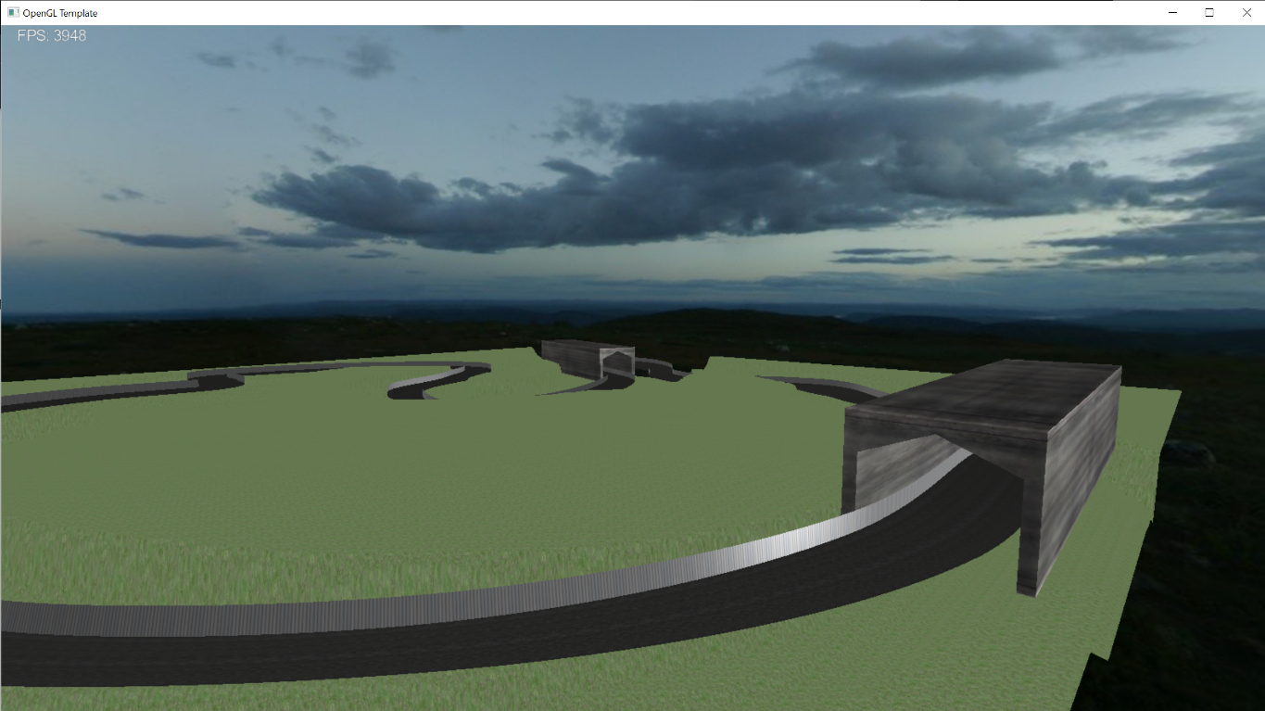

The second basic object I have added to my game is an overpass. My thinking was to create something that looked like a walkway to allow people at racetracks to cross the track safely. For now, this object is using the same shader as the one for the tunnel. However, down the line, I hope to implement a specific shader for the overpass which will allow for a 3d tessellation of my object. After applying a texture and placing multiple instances of the overpass into the scene, here is what the game looks like now:

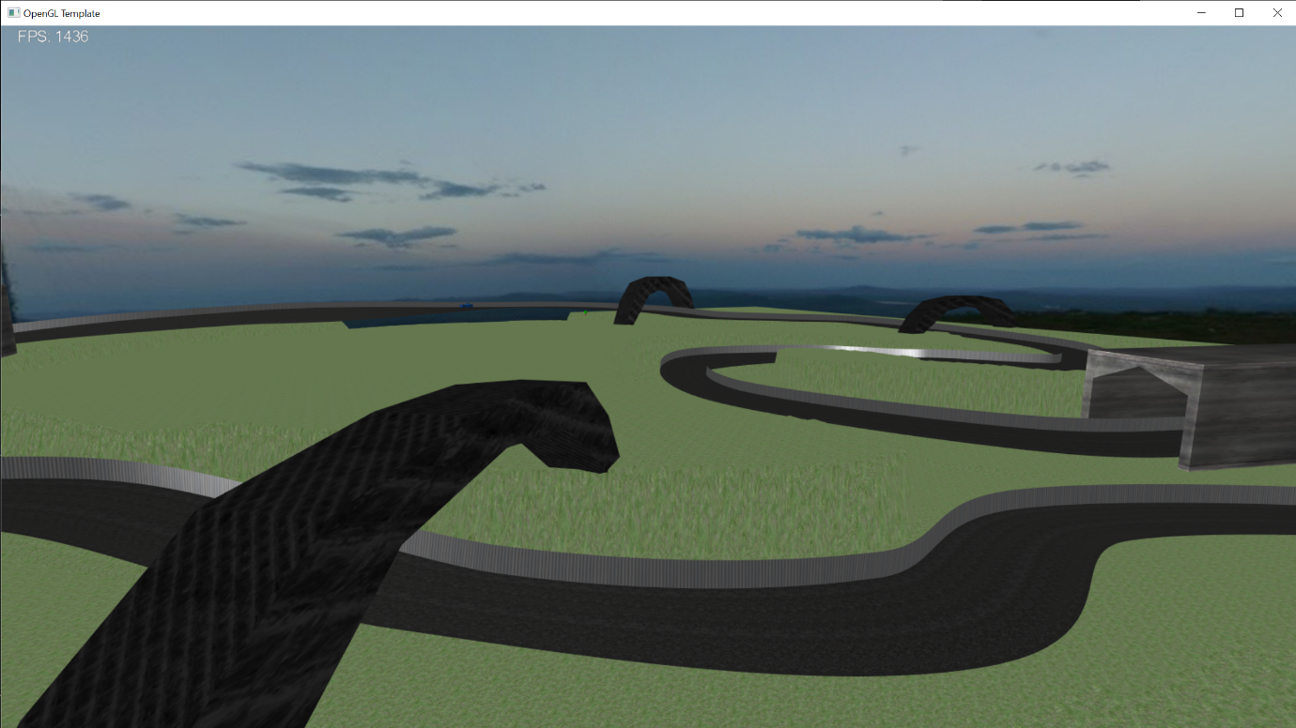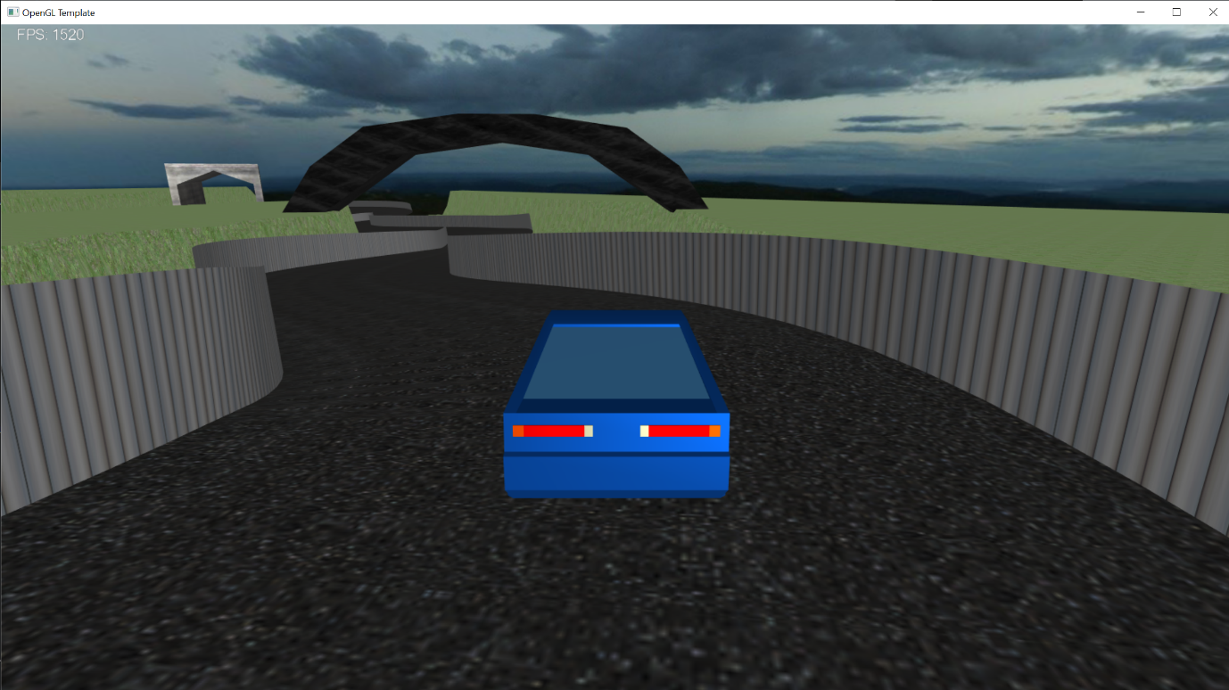

Meshes:

The first mesh I have implemented into my game is a car. This is the car that can be controlled by the player to play the level. The car is placed onto my track by setting its position based on the track’s centre line. The first-person camera and third-person camera are then set relative to the car’s current position. The car can then be controlled by the WASD keys which can move the car forward and backwards and left to right on the track. This is all done relative to the centreline of the track. To stop the car from leaving the track, I implemented a rudimentary collision system between the car and the barricade. The way this works is by simply checking, how far the car is from the centreline and not allowing it to go any further than a set limit. Lastly, I have set the mesh to rotate when the player presses either ‘A’ or ‘D’ to turn the car. This creates a very basic but effective animation to give visual feedback to the player when they are turning.

This is what the mesh looks like in the game from the third-person camera: 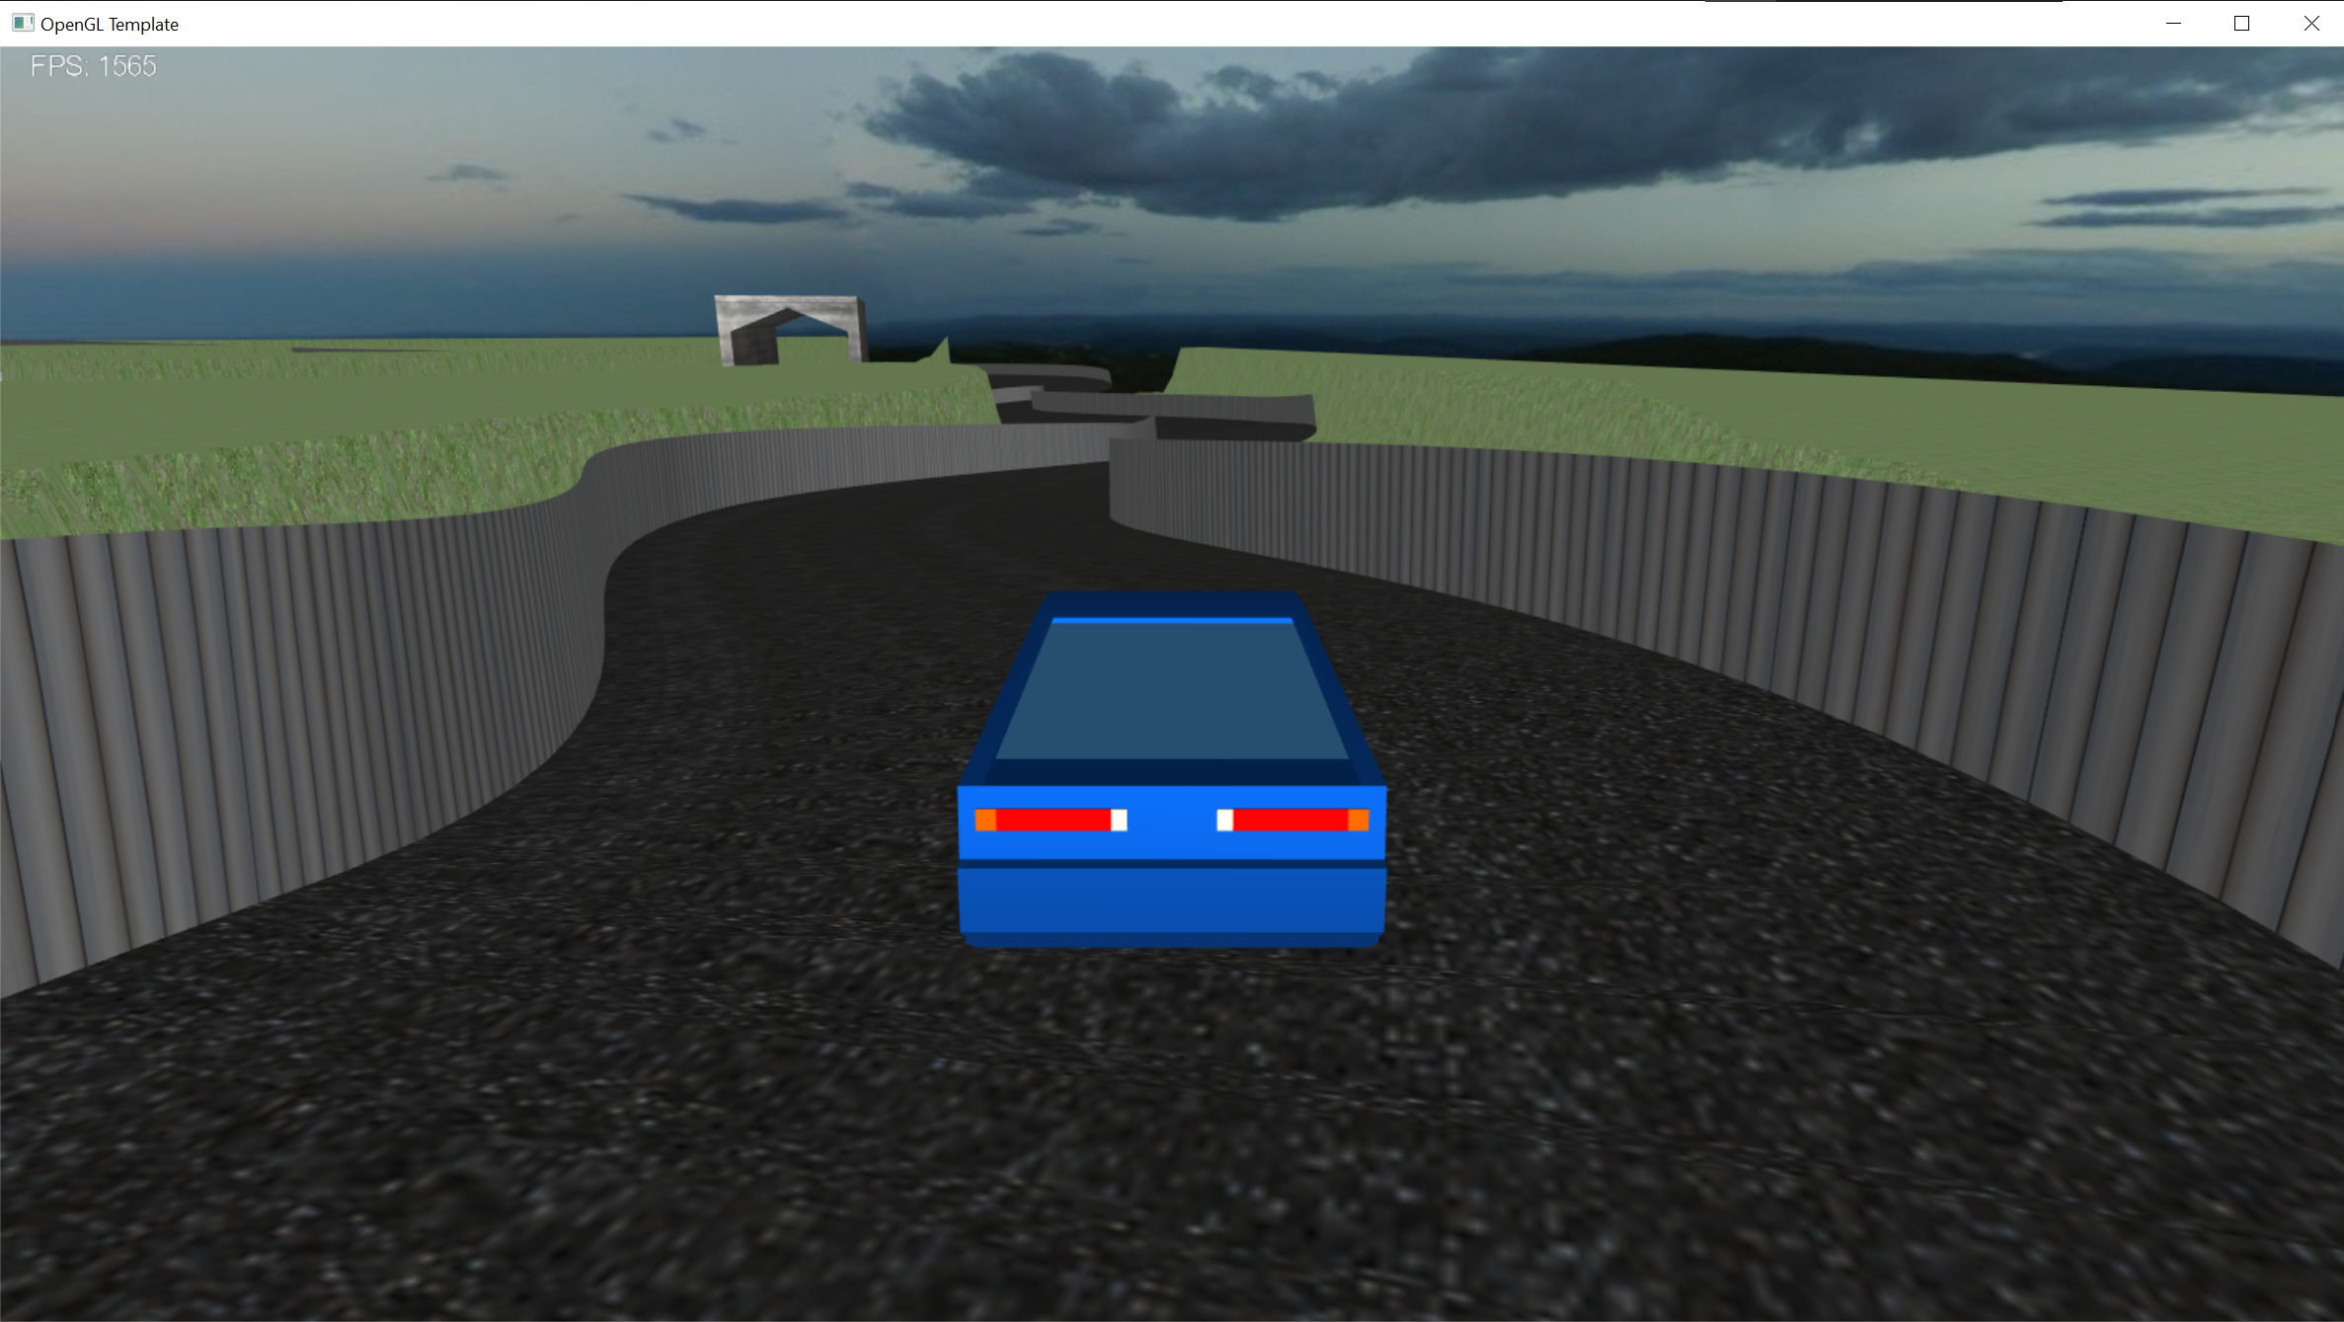

The second mesh I have implemented is a low poly tree that I used to improve the look of the terrain. Since I wanted to have hundreds of trees in my game, I used instanced rendering. This means all the information about an object and its various positions are sent to the GPU in one go, which is much quicker than the CPU sending information to the GPU on every render of a tree. However, I did run into a problem with this, due to the way meshes are rendered into the game using a single class. When I attempted to use instanced rendering for my tree, the GPU was also rendering x number of instances of all the objects in my scene. This dropped the frame rate significantly. To get around this, I created a separate class to load the trees, called CTreeMesh. This class is identical to COpenAssetImportMesh but doing it this way allows me to only use instanced rendering for the trees and nothing else, which improved performance.

This is what the game looks like with the new trees: